Erik Herbermann has very kindly allowed us to publish one of his articles on the website. Please note that this article is copyright protected and is reproduced here on condition that it is neither copied, reproduced or circulated in any way.

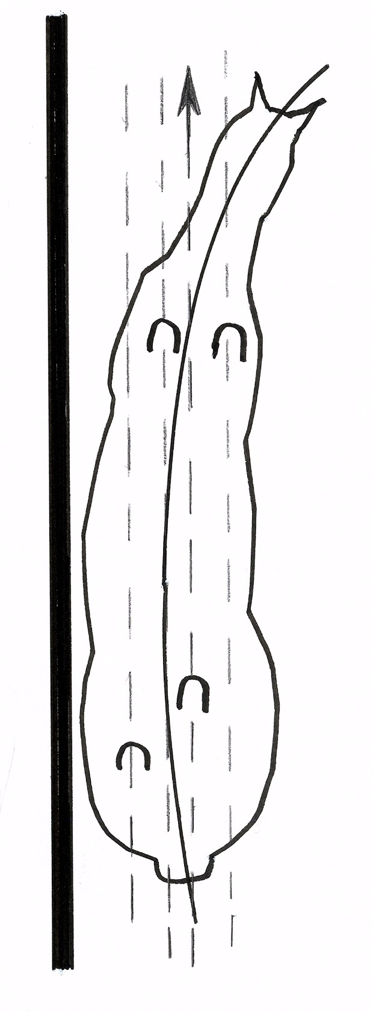

Figure 1 - True Shoulder Fore

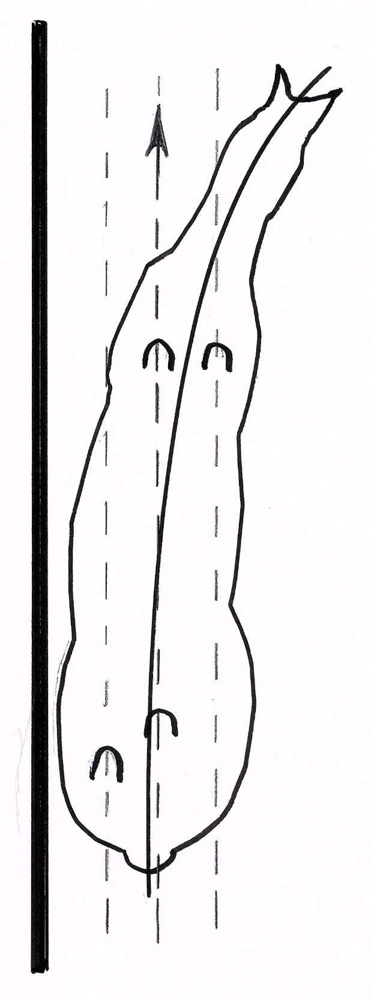

FIgure 2 - True Shoulder In

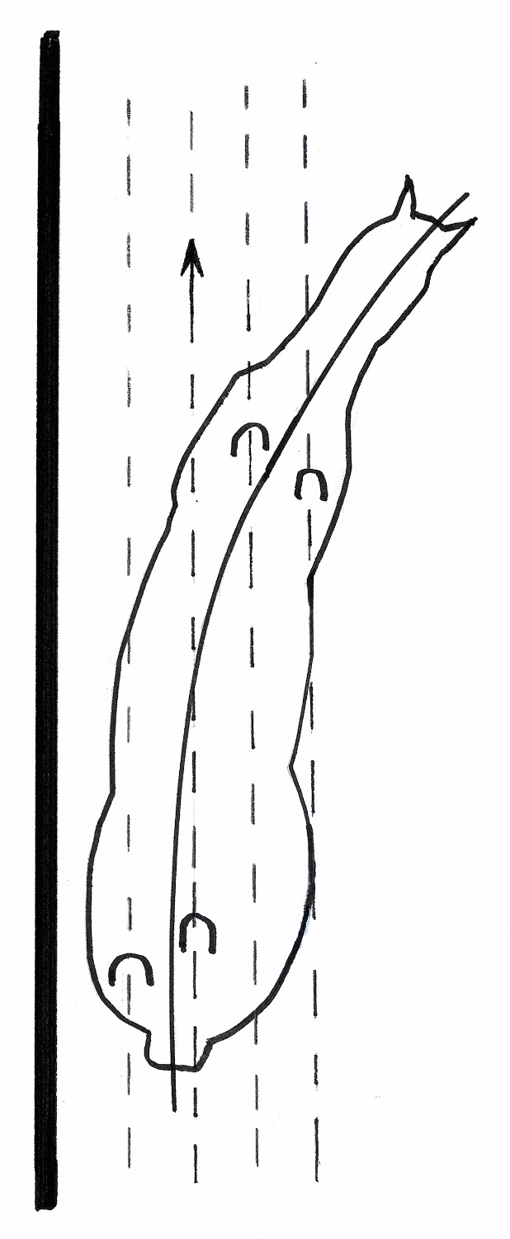

Figure 3 - Four Track Shoulder Fore

Thoughts on Shoulder-in

by Erik Herbermann

Erik Herbermann has given the Arrow Equestrian Website the first serial rights to publish this article. It is copyright material. Erik Herbermann 2016

Among the many exercises used in horsemanship, shoulder-in is surely among the most discussed and analysed. Over time, however, the foundation elements of shoulder-in often gradually become fuzzy while finding one's way through the complex forest of riding and training. In this article the most important components of shoulder-in are therefore revisited in detail and the common pitfalls to be avoided are outlined.

The technicalities

To begin, it is surely worthwhile to review briefly the foundation aspects of Shoulder-in. The exercise is based on one of the most important fundamentals of horsemanship: to establish alignment and balance, or to correct crookedness, by bringing the shoulders to line up in front of the hindquarters. The alternative, of trying to push the hindquarters over to align with the shoulders, usually results in unwanted fish-tailing or looseness of quarters and poor control over balance.

The classically accepted standard for shoulder-in is that it is done on three tracks (*Figure #2*):

* The inside front leg makes one track.
* The inside hind leg follows in the path of the outside front leg making the second track.
* The outside hind leg on its own path makes the third track

An indispensable mention: Shoulder-fore

Though we are dealing mainly with shoulder-in here, it is worthwhile to bring up briefly the significance of shoulder-fore (*Figure #1*). Despite its subtlety - actually, precisely because of it's subtlety (less is more!) - shoulder-fore is a valuable exercise for any horse and rider. Additionally, it is an important introductory tool for the training of young horses showing them in a gentle way to learn to respond to aiding which encompasses bend in forwardness and helps to align and liberate the shoulders.

Three-track, as opposed to four-track shoulder-in

We could discuss endlessly whether shoulder-in on three-tracks is better than on four-tracks. However, it is likely best to avoid being extreme. Each variation has its own value. Therefore, four-track may benefit some horses at times, depending on many underlying circumstances. For horses who are sufficiently advanced to benefit from shoulder-in, it has been well established that three-track work (*Figure #2.*) contributes better to the engagement, balance, elasticity and collection of the gaits. In four-track work (*Figure #3*), the shoulders are brought yet further inward, beyond the three-tracks and results in both front and hind legs crossing over. Because the angle is a bit more exaggerated, it may help the rider explain to horses, who seem a bit stiff or awkward, to respond better to the diagonal aiding principles and to the lateral seat bone/leg/knee aids. It is best for angles beyond the three tracks to be used sparingly and only temporarily.

What are the main seat and position requirements?

To achieve the fundamental requirement of having a correct bend through the horse's whole body for shoulder-in, we should follow these well-established guidelines:

* Have the inside seat bone forward (our hips parallel to the horse's hips). A word of caution: avoid letting the *energy* of the outside seat bone lag behind!
* We must turn the upper body inward from the waist (our shoulders parallel to the horse's shoulders).
* The inside lower leg must be forward (at, or just behind, the girth) and the outside leg should be about a hand's breadth further back.

The power of the mind

No one would argue that shoulder-in is a two-track exercise. Nevertheless, it will be found helpful not to *think* of shoulder-in as such. Because the very thought of 'two-track work' so often seems to cause riders to concentrate on shoving their horse sideways which tends to obstruct forward freedom of the gaits. Therefore, if we think of the exercise as a shoulder-in *attitude*, instead of shoulder-in *angle*, and imagine it to be just a facet of ordinary single-track work with a bend and a little inwardness of the shoulders, it gives wings to the gaits and allows a wonderfully productive, free-flowing movement to occur!

How is shoulder-in initiated?

The usual recommendation of starting shoulder-in by riding a volte is just fine. The volte helps establish that all-important bend around the *passive* post of the inside leg which should without exception remain at the girth. Then, we should think of doing that same volte again, only this time, as the horse *begins* to come off the wall *slightly*, give a half-halt which explains to the horse, "Let's not continue on with this volte!" At that very instant - with the upper body (and the rider's gaze) clearly turned to the inside - the inside seat bone, knee and lower leg *briefly* and clearly indicate to the horse the new 'energy' direction and attitude wanted: "OK, Sparkie, let's now flow along the arena wall like ***this*** (with the shoulder-in attitude)." It will be found helpful to practice alternating between riding single-track voltes, and then doing 5 to 10 steps of shoulder-in, then another volte followed by shoulder-in, back and forth between these two modes all the way up the long side of the arena.

The function of the inside leg

The main function of the inside leg is to excite forward energy. It is *not* the main job of the inside leg to shove the horse sideways! Only at the very instant of the transition - that is, from the single-track to the two-track position - does the inside seat bone, knee and lower leg *very briefly* give a ***forward-thinking*** lateral influence, showing the horse the change we want - it is helpful to think of pushing the girth forward at that moment. *The inside leg should strictly* ***not*** *be brought back to impart this brief redirecting-of-energy aid.* The exercise is called 'shoulder-in' - not 'shove the horse sideways', and especially not 'push the croup out'. Once the horse has taken on the shoulder-in attitude, simply flow up the arena wall as though you were doing ordinary single-track work while tending to the forward fluidity of the gait.

Two indispensable ingredients

1. The shoulder-in attitude is mainly initiated by the ***straight forward*** *animating or energizing aid* from the rider's inside leg (it may be backed-up with a tap of the stick or a reminder with the spur, if necessary).
2. Simultaneously, that energy is deflected off the *passive* presence of the outside leg which, acting *briefly* like a wall, automatically directs the energy up to the outside rein where it can be converted into balance with a half-halt. That diagonal aiding influence (inside leg AND outside rein [***not*** inside leg TO outside rein!]) is what balances the horse, liberates the horse's shoulders and allows them to be placed effortlessly to the inside by the deft 'feeling' influence of the outside rein. Though specific aids are being discussed here, they are always an integral part of the whole aiding orchestra.

The task of the outside rein

The outside rein plays a vital, multi-faceted role. It receives energy - like a cushion - and initiates or re-establishes alignment and balance. It skilfully sets up the desired two-track attitude and tends to the unified, aligning 'balanced energy' in the horse. Clearly, we must not only know how to ask for the shoulder-in, we must know how to allow it to happen. By 'having' the outside rein *without in any way blocking forwardness*, it allows the horse to flow in the desired direction without losing alignment of the outside shoulder from the dynamic 'energy stream'. Doing this well takes much sensitivity and experience on the rider's part. It does not take strength! It is essential to keep in mind that every aiding concept, including setting up shoulder-in, is strictly temporary. 'Give an aid - Get a response (a resolution)- Stop giving the aid!'

The moment of transition

Once we have set up the shoulder-in attitude as described above, and the horse has started to respond, we must delegate that to the horse. This is done by leaving the horse strictly alone (neutralize, relax the aiding), and implicitly trusting his intelligence and willingness. Hold nothing! Instead of holding, refresh the shoulder-in attitude, the balance, the energy and alignment as needed and then re-delegate that, time and time again. Just flow freely with the horse after each re-adjustment. Avoid the constant repetition, stride after stride, of the words in your own mind, "Shoulder-in, shoulder-in, shoulder-in". Horses are smart. Avoid over-controlling. Set them up, leave them alone. Let them do what you have asked and shown them to do. Monitor - Adjust - Trust. "I trust you, Sparkie, to go like ***this*** (shoulder-in attitude along the wall) on your own now!"

Pitfalls to be avoided

The following are common shoulder-in errors:

* Dominating with and/or pulling back on the inside rein. This leads to over-bending of the neck, cracking it off to the inside in front of the withers. This breaks up the horse's energies and prevents the horse from going in a unified, balanced way.
* Trying to shove the horse sideways by jamming the inside rein against the neck or withers. (As a small test, it should be effortless to keep the inside rein away from the neck - to the inside by 2-4 inches - and having a giving *attitude* with the inside hand during the shoulder-in exercise).
* Trying to shove the horse sideways constantly with the inside leg (instead of the inside leg doing its actual job of just generating forward energy - which the *passive* presence of the outside leg shunts to the bridle - and which the outside rein converts into balance. This, in turn, makes placing the shoulders to the inside easy).
* Falsely achieving the exercise by putting the inside leg back (or worse yet, back-and-up) towards the horse's flank or croup. In this case, the rider's mind - consciously or unconsciously - mistakenly wants to push the horse's body/croup outward and sideways - instead of thinking of the dynamic 'forward-inward' placing of the shoulders. To put the inside leg back also totally contradicts the foundation on which shoulder-in is built - *a correct inward bend of the horse's body around the* passive *post of the inside leg!* Correct bend cannot be caused or maintained when the inside leg is drawn back (we do not bend the horse *with* the inside leg. We bend the horse *around* the inside leg).
* It is also a common error to take the outside leg off during shoulder-in (or leg-yielding). The horse needs to be constantly 'sandwiched' between the inside and outside riding tools - reins, seat bones, knees and lower legs (see 'riverbanks', below).
* And the final common error to be avoided is for the rider to be looking up the wall of 5 the long side during shoulder-in, instead of always looking inward through the horse's ears, in harmony with the direction of the bend. Initially this inward looking may be exaggerated. One can experiment with this idea by alternately back and forth between looking well inward for several steps and then looking up the wall. It quickly becomes clear that horses flow much more freely when the rider looks inward.

The above-mentioned aberrations cause a stopping up of the horse's forward energies. They inhibit the freedom of the horse's shoulders and restrict the movement of the inside hind leg which leads to poor quality, broken gaits. Should such unwanted signs occur, it is important to abandon two-track exercises and to refresh the horse's forwardness by riding bright, forward working gaits on large, open school figures in single-track work, before trying the two-track exercise again.

Direct the energy through the 'riverbanks'

It may be found helpful to think of directing the horse's *energy* rather than his body; and to think of that energy as being water. The whole horse (but especially the shoulders) should literally flow lightly and freely between the rider's inside and outside riverbanks. The riverbanks are made up by the constant presence of our riding tools- the seat bones, knees, lower legs and reins - on each side of the horse. Forwardness 'waterproofs' those riverbanks.

Putting it all together

The various aspects of shoulder-in mentioned separately above, need to be skilfully integrated. Each aiding tool or instrument needs to play its part correctly while harmonizing with the others to produce the 'shoulder-in symphony'. These concepts, when combined, embody the subtle, interactive, diagonal aiding influences which are constantly in play and which either deftly re-align crookedness, attend to balance, or deliberately setup any of the accepted two-track attitudes.

In summarizing, though we may recognize that two-track work plays an important role in educating the rider and in the training and gymnastics of the horse, it should not be seen as an end in itself. It needs to remain a secondary adjunct to thoughtfully-applied school figures and exercises in *single-track work*. And that, without a doubt, should make up the bulk of our riding time.

Have a wonderful ride!

© Erik Herbermann. 2016