Erik Herbermann has very kindly allowed Arrow Equestrian to publish this article on the website. Please note that this article is copyright protected and is reproduced here on condition that it is neither copied, reproduced or circulated in any way.

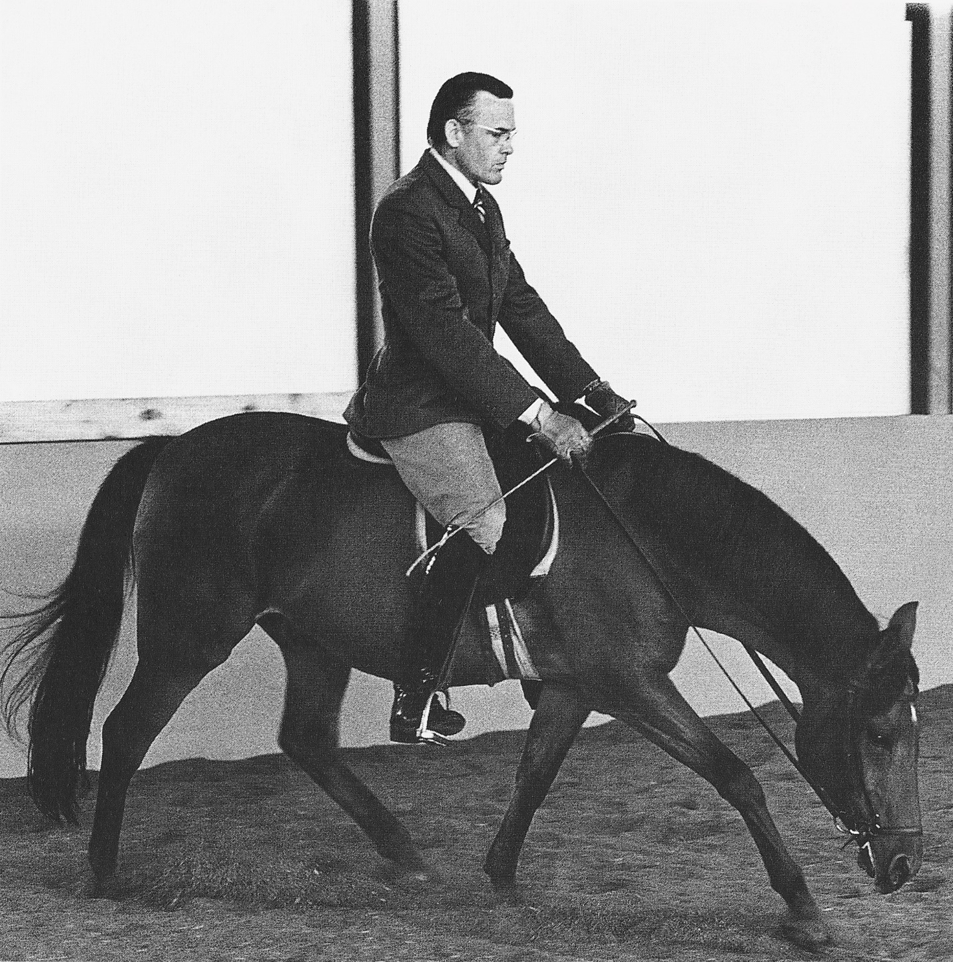

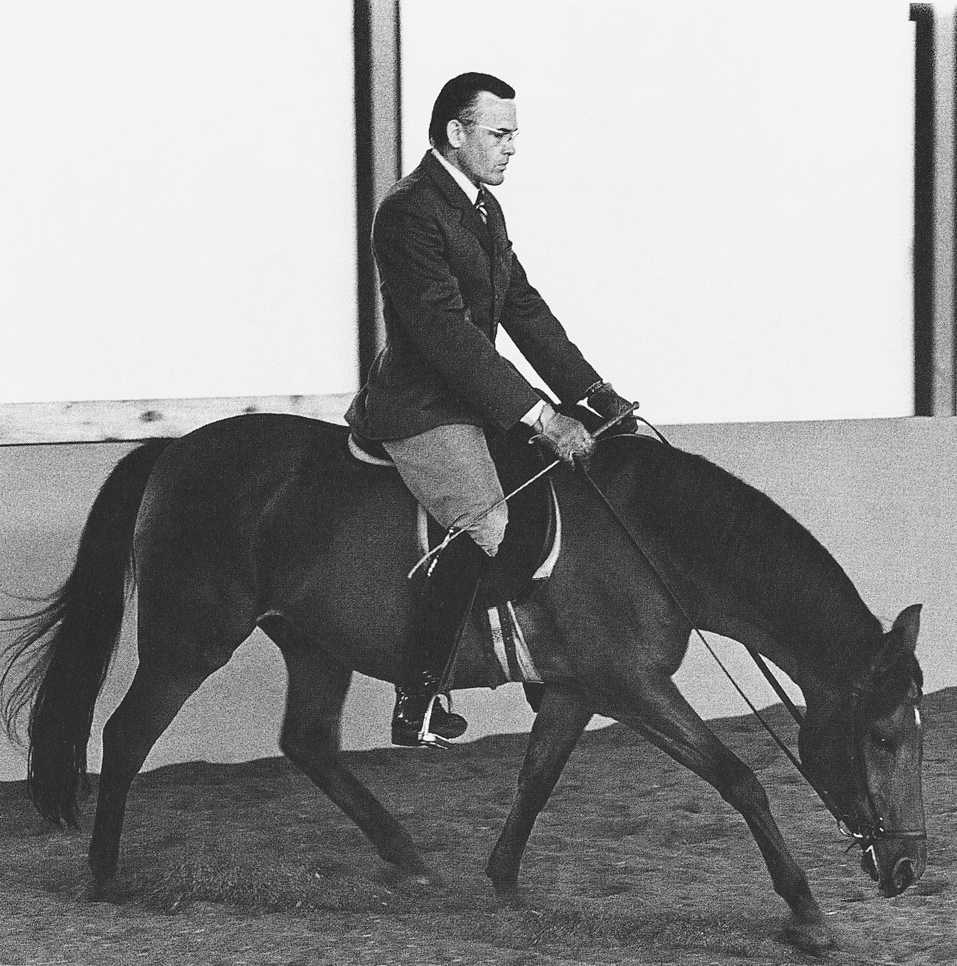

The Author on Barty. 'Forward and Down' at the working trot, sitting. The nose of the horse is correctly 'leading the way'. The horse's back is nicely up, carrying the rider forward with him. The withers are up. The contact is light and genuine. Photo by George Ross. Photo from Dressage Formula, 4th Edition (2008). With kind permission of the publishers, J.A. Allen, an Imprint of Robert Hale Ltd. London.

THOUGHTS ON FORWARD AND DOWNWARD STRETCHING   
relative to  
FACE BEHIND THE VERTICAL

Copyright: Erik F Herbermann, 2012

Many words, many concepts, countless articles 'pro' and 'con' on the issue of '*face behind the vertical*' relative to '*forward and downward stretching*' have appeared. It seems there are as many 'versions' and 'visions' as there are experts. How can we possibly wade through all of this information and know what is right, especially when some arguments may seem quite plausible?

**Where do we start?**  
Let's begin by getting one matter out of the way. For those who are sincerely dedicated to strive for classical standards, I believe we can agree on dismissing one 'method' of working the horse - the 'Roll Kur'. Next, when discussing 'right' (white) or 'wrong' (black) that we strive to stay away from personal 'opinion' as much as possible. However, it is important to accept that we will likely experience many shades of 'grey' as we practice and experiment on our way to discovering how to become ever more 'white' in our horsemanship. Our assessment of horsemanship needs to rest on deeper truths based on an authority outside of ourselves - that which is reflected in natural law. The wrinkle in all of this, however, is that even natural law is subject to each individual's greater or lesser capacity to evaluate its truths and to apply its principles. It is therefore clearly essential that we begin by setting ideals for which to strive.

**Seeking help . . .**  
Thankfully, there have been those who went before us who can help us establish solid, worthwhile ideals. They left us with excellent guidelines and observations about the horse's nature and how best to relate to and interact with it. Personally, I believe that among the many dedicated, intelligent masters of the past, that Wilhelm Müseler (*Riding Logic*) would have to be one of those great contributors to our equestrian understanding. In clear, everyday language he helps us to discover the horse's truth and how best to apply it in our daily practice. But that, of course, is the challenge, as it is with any theory . . . bringing his words to life in our own riding, on our own horses, each day again, until the concepts become an integral part of our actions. Even for dedicated students it takes much time to correctly develop the necessary feel and experience. It is therefore surely helpful to have some pretty good guidance from someone who has themselves brought that truth reasonably well into their own daily practice. The alternative would be to set about re-discovering the wheel!?

**Müseler's recommendations**  
Müseler unequivocally stresses the importance of 'showing the horse the way to the ground' ("Vorwärts-abwärts Reiten; i.e., forward and downward [F&D] stretching) **with the nose leading the way**! He repeatedly warned about avoiding having the horse come behind the vertical. He sees stretching the neck - because of adequate forward energy - as a foundation that the rider should be able to demonstrate at any time, in any gait - that it is an indispensable part of having the horse come correctly 'on the aids'. Interestingly - most worthy to note - he stresses especially that the actual forward stretching of the neck **with the nose leading** is itself more important than the 'downward' aspect, though it is best when both can be achieved.

**Egon von Neindorff's approach**  
During my 30-plus years of study at Egon von Neindorff's school in Karlsruhe, the F&D stretching with the nose leading was a normal, daily part of riding and training of all horses, whether novice or advanced. It has therefore always been an integral part of my horsemanship. Clearly, the better the seat and position, the more experienced the rider, the better and more correct the results would be. This was reflected particularly in its positive effect on the quality of the gaits.

**Playing 'scales'**  
If the reader will forgive me for stating the obvious, anything can be done well or poorly! Clearly, it is always more difficult to do things well. And the maddening thing is that success lies in paying attention to tiny details, those which we only seem to begin to recognize after years of 'playing scales' until the 'scales' drop from our eyes! I consider correct F&D stretching to be as difficult to do well as to ride a good piaffe. Logically, the good piaffe rests on the foundation of the F&D exercise done correctly.

**Am I perfect yet . . . ?**   
Does this mean that when we follow an ideal that we will always come up with perfect results? Of course not! To be dedicated to working in accordance with the horse's nature is always very challenging - the learning and refining of our interaction with the horse is never done. And though we may recognize the importance of trying to live by high standards, we also recognize that due to many circumstances we may not always be able to approach the ideal in practice. None of us is perfect. Even after years of thoughtful riding, there are days in which things work wonderfully for us, and days in which we experience difficulties. From horse to horse, there are also varying rates of development in F&D stretching. Some naturally well-balanced horses come to it quite easily. Others have greater difficulty, and require a creative, tactful, experienced rider and many months of patient work before some reasonable improvement is achieved.

**Signs of correct 'F&D'**   
Nevertheless, correct F&D riding is not mere 'wishful thinking'. Rather, it should be seen as an essential foundation to strive for, part of the very life blood of high quality horsemanship. Signs that the work is correct can be tested by riding F&D with the nose leading and alternating between that and bringing the horse 'up on the aids' again (back and forth). Through the whole procedure the 'energy connection' from the hindquarter to the bridle must remain. This is manifest by the horse's continuous, even stretching into the contact and remaining soft through the poll. When displayed by an experienced rider, the horse will remain in a steady, rhythmic gait and in a beautiful, independent, balanced state. The back will remain up and 'carrying'. And though the neck is stretching downward, the withers will still remain well 'up' in front of the rider, being full of impulsive, 'carrying energy'; and the horse will remain nicely in front of the rider's seat and legs.

**Signs of difficulties**  
However, for those riders who are not yet thoroughly practiced in riding F&D as Müseler recommends, the horse may well have the 'nose leading' but end up landing on the forehand, or dropping his back, or hanging his neck down in a slack, empty manner - or drop the contact and come behind the bit; or the opposite extreme, the horse may be lugging heavily on the bridle; or be snatching the bridle away in an attempt to free himself from a heavy-handed, or stiff rider. These, however, are all matters that need to be thoughtfully corrected and constitute a normal part of learning. But to judge or condemn the F&D stretching with the nose leading the way, possibly based only on one's assessment of what unskillful, or inexperienced (in this way of working) riders are capable of doing, is possibly just a bit unreasonable.

**Things . . . not always as they appear . . .**  
Almost anything in horsemanship can somehow be fabricated. I must hasten to add, this is most often done unwittingly and with the best of intentions. Things may even look pretty good (to the untrained eye) or feel pretty good if a horse has been trained over extended periods with, for example, the "90 degree - neck/poll" concept. But one approach can not be falsified: the F&D stretching with the nose leading the way fulfilling all the criteria mentioned above (Signs of correct 'F&D'). It takes time to learn it and when one is dedicated to do it correctly, then one will truly be able to experience what a horse can feel like when going in such a pure, unaffected way.

**Knowingness . . . unknowingness**  
Unfortunately, we dear humans are all to some degree 'unknowing' in some corner of human knowledge, relative to the vast amount of information available to us during these earthly lives. We all have occasionally suffered either because of our own or others 'unknowingness'. We only have to think about how many truly great 'Visionaries' from the past were terribly mistreated by the 'authorities' who's judgement relied on the science of the time, and were later proven to be (let's be kind) 'not quite right'. (Just to mention a few obvious cases: 'The earth is the centre of the universe'; 'The earth is flat'). But one can't blame them for that. They acted on what they knew. That's really all we can expect from anyone, including ourselves. Clearly, our 'science' needs to grow, but so much depends on our individual perceptive acuity as we gradually grow in experience and understanding.

**Dedication**  
F&D stretching in the manner described by Müseler is not something one tries for a day or two after having ridden for decades using 'another' dressage approach. If one has not diligently tried to practice it correctly over many years on many different horses, it is little wonder that one might dismiss it as impracticable, just because results are not quickly forthcoming. For me personally, however, this approach has irrefutably stood the test of time. I feel that, if we wish to elevate our horsemanship to a finer level, it is essential to strive for an ideal standard established over centuries by many dedicated, intelligent masters - however hard that might be to fulfill and however often I may fail in the trying. That, rather than lowering my standards to suit my own level of ability, or inability - relative to that standard - on any given day.